**问题—解决模式Problem-Solution**的宏观结构一般由**情景（situation)、问题(problem)、反应(response)、评价(evaluation)或结果(result)**四个成分组成各成分既可以由—个小句或句子充当，又可以由两个或更多句或句子组成。其中“情景”有时在某类语篇（如广告等）中可有可无,“反应”指解决问题的办法,“评价或结果”有三种可能：一是肯定评价后再提供“依据、理由”（basis）这个依据或理由可有可无；二是肯定结果后再提供肯定评价，这个肯定评价可有可无；三是肯定结果和评价结合在—表述中。如图所示 ( Hoey , 2001 : 127 )：

Situation (optional)

↓

Aspect of situation requiring a response (problem)

↓

Response

Positive evaluation positive result Positive result /evaluation combined in a single statement

↓ ↓

Basis (optional) Positive evaluation (optional)

一般来说，问题-解决模式的结束标志是对“问题”提出了有效的解决方式，提供了肯定的评价（或结果）但如果采取的“反应”可能没有或完全没有解决问题，评价或结果是否定的，语篇生产者可能转而求助于其他解决办法，这样问题-解决模式就会出现循环直至找到有效的解决办法。如图所示（Hoey , 2001 : 130 ) :

Situation (optional)

↓

problem

↓

Response

Negative evaluation and/or result Positive evaluation and/or result

问题-解决模式是英语中极为常见的语篇模式, 经常用于**说明文、广告、科技文章、实验报告、新闻报道以及故事、小说等文学作品中**。同时该模式在词汇标志(lexical signals) 方面也有其鲜明的特色。最突出的莫过于语篇中有时出现problem 、solution、result等明显的词汇标志。McCarthy ( 2002 :79) 对该模式各组成成分中经常出现的词汇标志作了小结：问题成分的词汇标志有concern、difficulty、dilemma、drawback、hamper、hind ( er /ance)、obstacle、problem、snag等；反应的词汇标志有change、combat、come up with、develop、find、measure(s)、respon(d/se)等；解决与结果的词汇标志有answer、consequence、effect、outcome、result、solution、(re)solve等；评价的词汇标志有(in)effective、manage、overcome、succeed、( un ) successful、viable、work等。

**一般―特殊模式General- particular**又可称作概括—具体模式（General- specific pattern）该模式的宏观结构由三个成分组成：概括陈述、具体陈述和总结陈述。总结陈述则是对语篇内容的总结，但不一定每一语篇都得有；若具体陈述已把概括陈述的观点阐明时，总结陈述可以没有这种模式有两种表现形式：一是先概括后举例（Generalization- Example）其特点是：概括陈述阐明主题来统领整个语篇，然后具体陈述对概括陈述进行举例论证；二是先整体后细节（Preⅵew-Detail），其特点是：概括陈述给出总体轮廓来统领整个语篇，然后具体陈述对概括陈述进行细节论证。所谓细节论证，就是采用描绘细节或通过数字统计来说明概括陈述的一般事实或一个道理。如图所示（McCarthy， 2002 ： 158 ）：

A:

General statement

↓

Specific statement 1

↓

Specific statement 2

↓

Specific statement 3

↓

Etc…

↓

General statement

B:

General statement

↓

Specific statement

↓

Even more specific statement

↓

Even more specific statement

↓

Etc…

↓

General statement

该模式在推销宣传材料中很典型，除此之外，不仅在自然科学、社会科学的论文中屡见不鲜，在文学巨著、百科全书中页常常看到。

**主张-反应模式Claim- response**，又可称为主张-反主张模式(claim-counterclaim pattern)或假设-真实模式(hypothetical- real pattern)。该模式的宏观结构有**“情景”、“主张”、“反应”**等三个组成部分，而情景很多情况下是可有可无的，所以说该模式的核心部分就是主张与反应。在主张部分，作者陈述他人或自己的已经说过的但没有认同其真实性的观点和情况，有时可根据需要同时提供该观点或情况的理由，在反应部分，作者对主张部分中的观点或情况的真实性，阐明自己的看法或观点，即支持或反驳、肯定或否定（修正）主张部分提出的观点或情况，并一般给出相应的理由。需指出的是，反应有时不一定是作者本人的看法或情况，而是作者提出另一方的反主张或者是描述真实的情况。

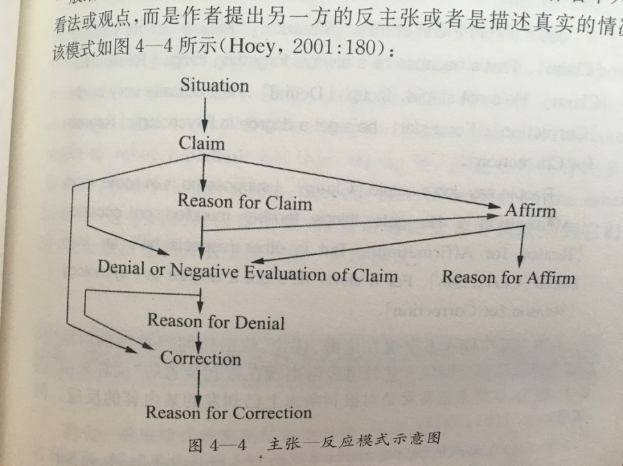

从这个图不难看出，该模式的主要结构是主张与反应两部分，只是作者的反应可以有多种可能，如对前面的主张部分中的观点或情况的肯定、否定、修正、否定后再修正以及肯定后再否定或修正等。值得注意的是，Hoey认为主张部分有时都不一定非得出现，模式直接就从否定开始。

主张-反应模式多出现在论辩、评论、政治新闻等类型的语篇中，是这类语篇的典型模式，此外也经常出现在报刊杂志的“读者来信”语篇中，因为这些来信常常是对报刊杂志上已刊发的某内容的反应。

Winter（1994）对主张-反应模式的词汇标志作了小结，主张部分的词汇标志有assertion, assumption, belief, claim, conclusion, expect, feel, guess, illusion, image, proposition, rumor, speculation, suggestion, suppose, theory, think等；在反应部分表示支持肯定的词汇标志有affirm, agree, confirm, concur, evidence, fact, know, real, right, true等；表示反驳否定的词汇标志有contradict, challenge, correct, deny, dismiss, disagree, dispute, false, lie, mistake, object to, rebut, repudiate, not true, wrong等。除这些外，还有许多如state, acknowledge, accept, false, in fact, in reality, on the other hand等, 这些词汇标志作用很大，当语篇接受者听到或见到他们时，就会激活他们大脑里的主张-反应模式。

Opportunity- taking

机会-获取模式的宏观结构由情景、机会、获取、结果组成。情景可有可无，模式通常从机会出现开始，往往会有明显的模式词汇标志，如offer, opportunity等，同时还常常有像unique, special, usual, understanding, once in a lifetime, once in a blue moon等词语与他们连用，结果要么是肯定的结果，或无法弥补的否定结果，要么是可弥补的否定结果，如果是可弥补的否定结果，模式只会循环。机会-获取模式多用于广告，报刊启事，商务英语，叙述语篇当中。

Situation (optional)

↓

Opportunity

↓

Taking

Positive result / negative result not beyond retrieval

Irretrievable negative result

Question – answer

提问-回答模式一般是在语篇的开头提出一个问题，随后语篇的展开，主要是寻求对所提问题的令人满意的回答。其宏观结构是情景、提问、回答与肯定或否定评价，但主要组成成分是提问、回答。情景可有可无，肯定评价预示语篇的结束，但有时也可以不出现，但若对回答是否定评价，则预示着模式的循环，直到令人满意的回答。

提问-回答模式与问题-解决模式有相似之处，但提问-回答模式有其明显的特点，一是提问-回答模式通常在语篇开头有显性的带有疑问号的疑问句。二是该模式的主要动机是寻求一个令人满意的回答。三是提问回答模式是匹配比较型(matching pattern)，而不是序列型模式(sequence pattern)，主要通过重复法获得信号标志，提问与回答之间没有逻辑顺序关系。对于序列型的问题-解决模式主要组成部分之间有着因果关系。

提问- 回答模式应用广泛，经常出现在演说、政论、说教、报道等较长的语篇中 。

Situation (optional)

↓

Question

↓

Answer

Rejection Positive evaluation

## The “Greener Grass” Syndrome

Have you ever met the situation where you kept thinking that there are better opportunities out there compared to your current one you are having? This is the syndrome when one is always looking at the other side of the fence and think that the grass is greener there. This is what I call the “greener grass” syndrome.

Why are you like this? Uncertainty and curiosity play a big part in creating the “greener grass” syndrome. It is because we are uncertain of whether what we are holding onto now is the best for us and whether there are any better alternatives out there. Such uncertainty causes us to keep looking into alternatives. In fact, it sometimes does us more harm than good because consistently looking out for the “greener grass” will sap us of our energy and attention and ultimately we can grow even angrier, or at least more dissatisfied.

Humans are also curious by nature and we love new things. We mostly prefer new over old because new things are fascinating and our curiosity keeps reminding us to explore the other side of the grass. These are the two factors that cause us to feel unsatisfied with what we have and always thinking of finding the greener grass at the opposite side.

If you have this syndrome, chances are you are missing out lots of things you currently have now. When you are always focusing on other opportunities, sometimes you may waste the opportunity right in front of you.

So what can you do to cure the “greener grass” syndrome? The first thing is to recognize that your current job is your best choice right now. Try to focus on “what is” instead of “what if”. Secondly, always apply your best efforts in your current job. Otherwise, what can you make out of your job when you hardly devote any effort? Last but not least, always keep this truth in mind. The grass is always greener on the other side, *and* the other side is always greener no matter which side you are at. Choose a side, stick to it and make the best out of it.

材料解读梳理：

① 主题与知识

1. 主题思想与语言知识

1’ How to overcome the“greener grass”syndrome

2’ 语言知识(话题信息知识 – 词汇)

|  |  |
| --- | --- |
| green grass | greener grass |
| the current one you are having | better opportunities |
| alternatives | better alternatives |
| chances | better chances |
| choice | better choices |

② 语篇知识（语篇组织与语言特征）（理解）：

1’. 语篇组织模式(text type): 问题-解决 problem – solution

“greener grass”syndrome

Uncertainty and curiosity play a big part in creating the “greener grass” syndrome.

Fact & reason

Humans are also curious by nature and we love new things.

does us more harm than good sap us of our energy and attention grow even angrier

more dissatisfied cause us to feel unsatisfied missing out lots of things

waste the opportunity right in front of you

Cause & effect

The first thing is to recognize that your current job is your best choice right now. Try to focus on “what is” instead of “what if”.

Last but not least, always keep this truth in mind. The grass is always greener on the other side, *and* the other side is always greener no matter which side you are at. Choose a side, stick to it and make the best out of it.

Secondly, always apply your best efforts in your current job. Otherwise, what can you make out of your job when you hardly devote any effort?

2’ 段落文本结构 （text organization structure）

Fact & reason：

|  |  |
| --- | --- |
| Uncertainty and curiosity play a big part in creating the “greener grass” syndrome. | play a big part in... |
| It is because we are uncertain of whether what we are holding onto now is the best for us and whether there are any better alternatives out there. | It is because... |
| Such uncertainty causes us to keep looking into alternatives.  These are the two factors that cause us to feel unsatisfied with what we have and always thinking of finding the greener grass at the opposite side. | causes ... to... |
| We mostly prefer new over old because new things are fascinating and our curiosity keeps reminding us to explore the other side of the grass. | because... |

Cause & effect

|  |  |
| --- | --- |
| In fact, it sometimes does us more harm than good because consistently looking out for the “greener grass” will sap us of our energy and attention and ultimately we can grow even angrier, or at least more dissatisfied.  ......These are the two factors that cause us to feel unsatisfied with what we have and always thinking of finding the greener grass at the opposite side.  If you have this syndrome, chances are you are missing out lots of things you currently have now. When you are always focusing on other opportunities, sometimes you may waste the opportunity right in front of you. | does us more harm than good  sap us of our energy and attention grow even angrier  more dissatisfied cause us to feel unsatisfied missing out lots of things  waste the opportunity right in front of you |

2-1. 语篇语用 → 建议观点表达

The first thing is to recognize that your current job is your best choice right now. Try to focus on “what is” instead of “what if”.

Secondly, always apply your best efforts in your current job. Otherwise, what can you make out of your job when you hardly devote any effort?

Last but not least, always keep this truth in mind. The grass is always greener on the other side, *and* the other side is always greener no matter which side you are at. Choose a side, stick to it and make the best out of it.